**Project 18：Small Fan**

1. **Introduction**

In the hot summer, we need an electric fan to cool us down, so in this project, we will use a Raspberry Pi Pico to control 130 motor module and small blade to make a small fan.

1. **Components Required**

|  |  |  |
| --- | --- | --- |
| 17a6d7f241a04d4e932cb06b758197c4 | _DSC2552 | |
| Raspberry Pi Pico\*1 | Raspberry Pi Pico Expansion Board\*1 | |
| KS6038 130电机驱动模块 | 杜邦线-3 |  |
| 130 Motor Module\*1 | M-F Dupont Wires | USB Cable\*1 |

1. **Component Knowledge**

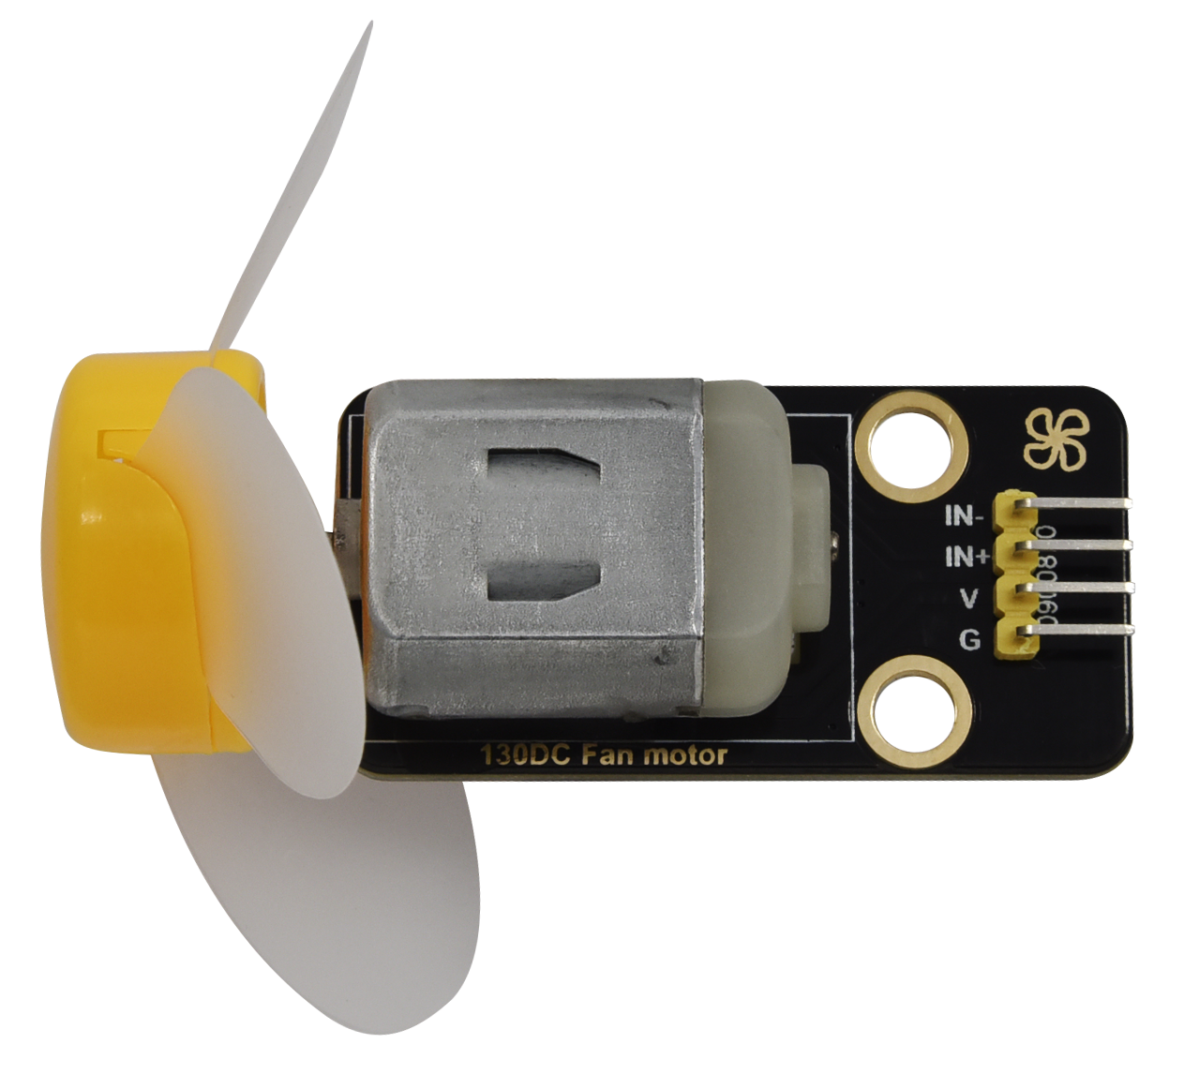

130 motor module: The motor control module uses the HR1124S motor control chip, which is a single-channel H-bridge driver chip for DC motor. The H-bridge driving part of the HR1124S features low on-resistance PMOS and NMOS power tube. The low on-resistance ensures low power loss of the chip, making the chip work safely for a longer time. In addition, HR1124S has low standby current and low quiescent current, which makes HR1124S easy to be used in toy scheme.

Features:

Working voltage: 5V

Working current: 200MA

Working power: 2W

Working temperature: -10℃~ +50℃

**Schematic diagram:**



1. **Circuit Diagram and Wiring Diagram**

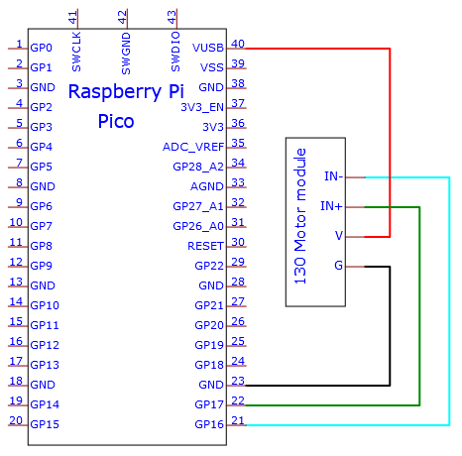

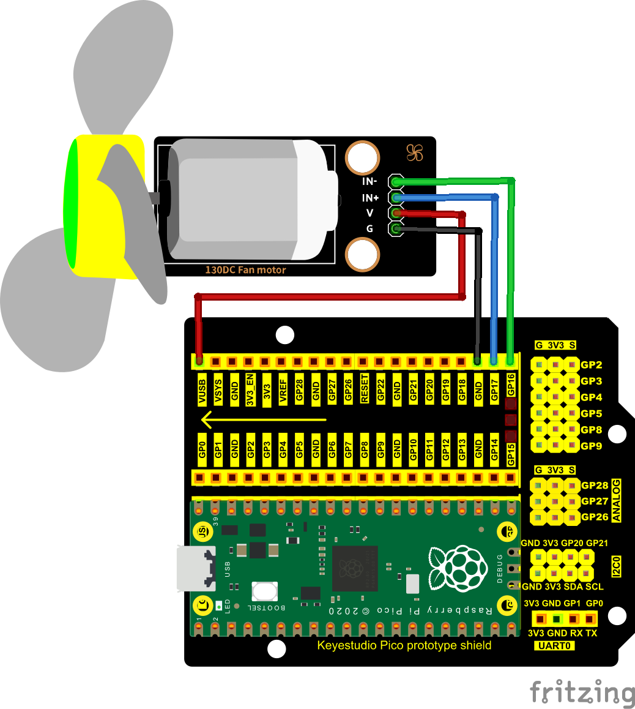

1. **Test Code**

The code used in this project is saved in the file S3020 Keyestudio Raspberry Pi Pico Learning Kit Ultimate Edition\3. Raspberry Pi System\Python\_Tutorial\2. Projects\Project 18：Small Fan.

You can move the code anywhere. We save the code to the pi folder of the Raspberry Pi system. The path:home/pi/2. Projects

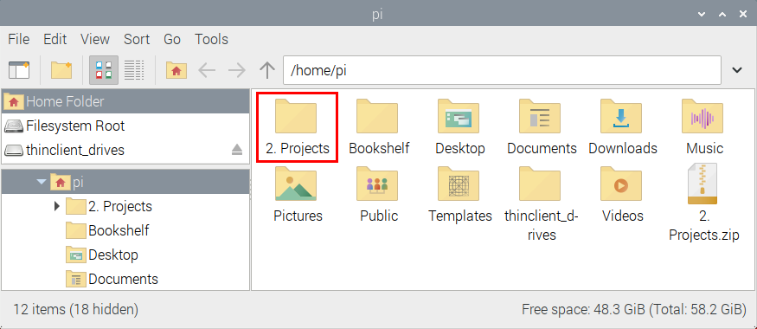

Open“Thonny”, click““This computer”→“home”→“pi”→“2. Projects”→“Project 18: Small Fan”. And double-click the“Project\_18\_ Small\_Fan.py”.

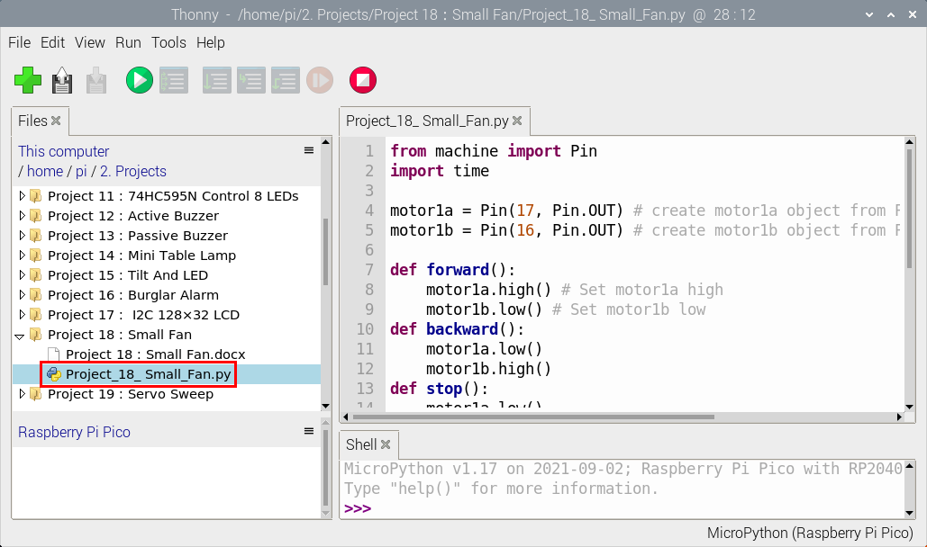

|  |
| --- |
| from machine import Pin  import time  motor1a = Pin(17, Pin.OUT) # create motor1a object from Pin 17, Set Pin 17 to output  motor1b = Pin(16, Pin.OUT) # create motor1b object from Pin 16, Set Pin 16 to output  def forward():  motor1a.high() # Set motor1a high  motor1b.low() # Set motor1b low  def backward():  motor1a.low()  motor1b.high()  def stop():  motor1a.low()  motor1b.low()  def test():  forward() # motor forward  time.sleep(5) #delay  stop() # motor stop  time.sleep(2)  backward()# motor backward  time.sleep(5)  stop()  time.sleep(2)    for i in range(5):  test() |

1. **Test Result**

Ensure that the Raspberry Pi Pico is connected to the computer，click“Stop/Restart backend”.

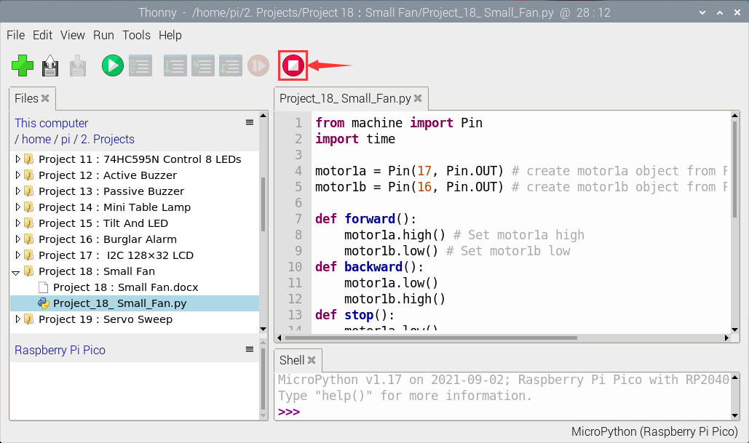

Click “Run current script”, the code starts executing, we will see that The small fan turns counterclockwise for 5 seconds and stops for 2 seconds, and then turns clockwise for 5 seconds and stops for 2 seconds. Repeat this rule for 5 times and then the small fan stops. Click“Stop/Restart backend”to exit the program.

